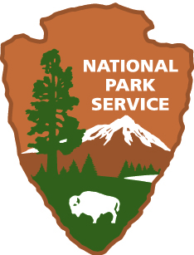

NATIONAL PARK SERVICE

APPALACHIAN NATIONAL SCENIC TRAIL

APPALACHIAN TRAIL PARK OFFICE

STRATEGIC PLAN

Long-term Goals for
Fiscal Years 2008 -2012

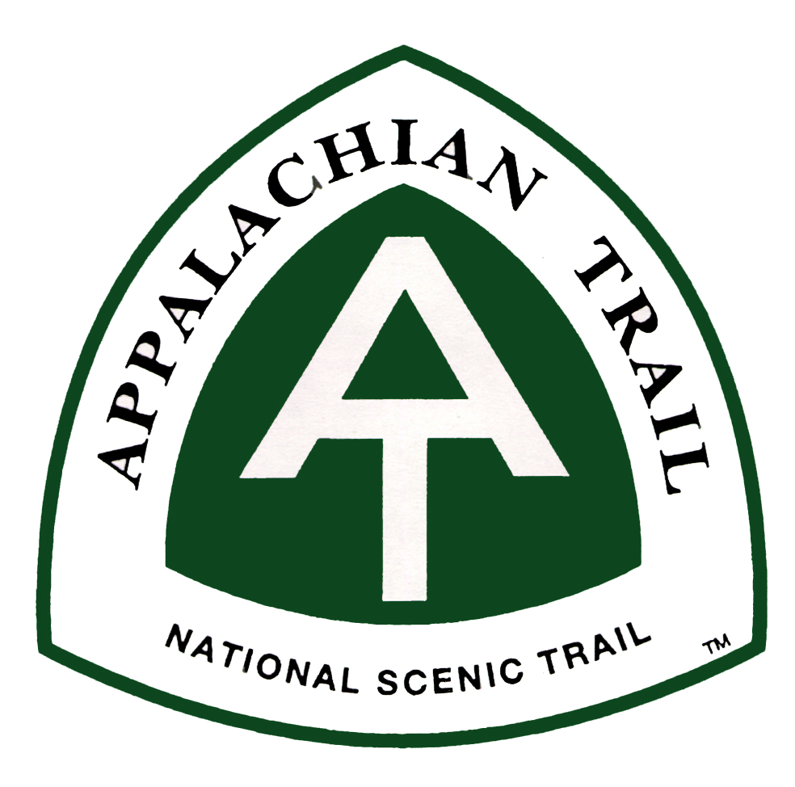

APPALACHIAN NATIONAL SCENIC TRAIL
APPALACHIAN TRAIL PARK OFFICE

FISCAL YEAR 2008 – 2012

(October 1, 2007 – September 30, 2012)

Strategic Plan

for

APPALACHIAN NATIONAL SCENIC TRAIL

Approved: _____________________________ _____________
Park Manager Date
I. INTRODUCTION

The Appalachian National Scenic Trail

Established as the first National Scenic Trail by Congress with passage of the National Trails System Act in 1968, the Appalachian National Scenic Trail (A.T.) is a continuous marked footpath extending approximately 2,175 miles across the Appalachian Mountains from the summit of Springer Mountain in Georgia to the summit of Katahdin in Maine, forming a greenway that connects more than 90 public land areas in 14 states. Preserved within this greenway is the remarkable story of citizen action in the public interest, along with a premier outdoor recreation opportunity and a wide variety of natural and cultural resources making the A.T. a valuable part of America’s heritage.

The initial route of the A.T. was constructed almost entirely by volunteers between 1923 and 1937, building upon the concepts of Benton MacKaye, a forward thinking landscape architect and conservationist. Since that time, volunteers affiliated with the Appalachian Trail Conservancy (formerly Conference) (ATC) and its 30 member trail clubs have planned, constructed, reconstructed, and maintained the footpath, as well as a system of more than 275 shelters and associated facilities.

In 1968 Congress recognized that, “Although member clubs of the conference have shouldered responsibility for many miles of the trail, and at times have been forced to relocate segments away from the path of developments, the demands of an expanding population have multiplied in number and complexity in recent years and long stretches of the trail are seriously threatened with incompatible encroachments. These are the problems which the conference has insufficient means to combat. If the trail is to survive, it is apparent that public agencies must assume a larger share of the burden of protection (1968, Senate Report)”. Today, with more than 165,000 acres acquired by the NPS and the USFS as part of a permanent right-of-way and protected corridor, the Appalachian National Scenic Trail ranks both as a component of the national trails system and a unit of the national park system. Its remarkable decentralized, volunteer-based cooperative management system further sets it apart as a premier example of a partnership program involving all levels of government and private citizenry engaged in the cooperative management of a nationally significant public resource.

As directed by the National Trails System Act, the Appalachian National Scenic Trail Advisory Council (ANSTAC) was established in 1978 for a period of ten years and included representatives from the NPS, USFS, Tennessee Valley Authority, Smithsonian Institution, ATC and each of the 14 Trail States. One of the primary purposes of the Council was to advise the NPS in regard to the administration of this newly designated national scenic trail. The Council, like Congress recognized the role of ATC and multiple other partners within a unique and complex cooperative management system. In 1984 an unprecedented NPS delegation agreement was signed with ATC, which delegated management authority to the Conservancy and in turn to the 30 trail maintaining clubs. Prior to the termination of the Council in 1988 a memorandum of understanding was signed between all of the council members committing their agencies and organizations to the protection and management of the Trail and identifying the Cooperative Management System as the management prescription to be followed by all participants.

Based upon the recognition of Congress and the commitment of ANSTAC, the NPS continues to recognize that direct land management responsibility for the Trail lies with ATC and the citizen volunteers of its member trail clubs. Today the Appalachian Trail Park Office (ATPO) has agreements with the USFS, 6 other units of the NPS and each of the 14 states through which the Trail passes recognizing the role of ATC and its member clubs and identifying the roles of individual agencies in the Cooperative Management System of the A.T.

A cooperative agreement between NPS and the ATC provides the cornerstone of the innovative A.T. Cooperative Management System. In FY 2009, the NPS ATPO provided $1.76 Million from various funding sources to ATC through the cooperative agreement for A.T. management activities, which was matched by substantial financial contributions and more than 6,300 individual volunteers contributing more than 202,000 hours of labor dedicated to planning, management and maintenance of the trail.

It should be noted that the Appalachian Trail Conference formally changed its name to the Appalachian Trail Conservancy in July, 2005. For the purposes of this plan, historical references utilize the term “conference.” The majority of references utilize the acronym “ATC,” which remains the same.

II. MISSION

The mission statement of the Appalachian Trail Park Office grows from the Appalachian National Scenic Trail’s legislated mandate found in the National Trails System Act. Our mission statement is a synthesis of our mandated purpose and the trail’s primary significance.

Mission: It is the Mission of the Appalachian Trail Park Office to foster the Cooperative Management System of the Appalachian National Scenic Trail in order to preserve and provide for the enjoyment of the varied scenic, historic, natural and cultural qualities of the areas between the states of Maine and Georgia through which the Trail passes.

Purpose: The Appalachian National Scenic Trail will be administered primarily as a footpath in cooperation with the United States Forest Service, the Appalachian Trail Conservancy and the 14 States encompassing the Trail, providing for maximum outdoor recreation potential as an extended trail and for the conservation and enjoyment of the nationally significant scenic, historic, natural, and cultural resources of the areas through which the Trail passes.

Significance: The Appalachian Trail is a way, continuous from Maine to Georgia, for travel on foot through the wild, scenic, wooded, pastoral, and culturally significant lands of the Appalachian Mountains. It is a means of sojourning among these lands, such that visitors may experience them by their own unaided efforts. The body of the Trail is provided by the lands it traverses, and its soul is in the living stewardship of the volunteers and partners of the Appalachian Trail Cooperative Management System.

Legislative Intent: The House and Senate reports along with the Congressional Record as part of the legislative history of the National Trails System Act, clarify Congress’s intent for the following elements of the Appalachian National Scenic Trail’s mission, purpose and significance statements:
1. “Primarily as a footpath” – The only recognized divergence from use solely as a footpath is horseback riding, where it is an accepted and customary or traditional use.
2. “Maximum Outdoor Recreation Potential” – This phrase is used only in the context of the Trail’s length and location as an extended trail, rather than types of use. All references to this phrase throughout the legislative history are in the context of the Trail’s location to urban areas or in reference to the length of use as, “…a few hours at a time, or on one day jaunts, overnight treks, or expeditions lasting a week or more.” There is even reference to volunteer work as a recreational activity, “Their work on the trail has been as important an outdoor recreation activity to them as the enjoyment of hiking and camping along the trail.”
3. “Volunteers and private nonprofit trail groups” as referenced in the National Trails System Act is recognized for purposes of the Appalachian National Scenic Trail as the Appalachian Trail Conservancy and its member trail maintaining clubs - “The committee recognizes that the Appalachian Trail Conference has pioneered the way for this legislation by its long-time personal stewardship of the trail, and believes that its stewardship – in partnership with the Secretary of the Interior – should be continued and expanded.”

III. STRATEGIES: Accomplishing Goals

ATPO plans to accomplish the goals using the organization, facilities, and financial resources summarized below. These paragraphs should give partners, stakeholders, and the public a better understanding of what ATPO is trying to accomplish, and the plan to do it.

Organization

Park Manager, Pamela Underhill leads the Appalachian Trail Park Office (ATPO). With a staff of only 9 NPS employees , the ATPO is not organized into the typical operating divisions of other national park units of comparable size. ATPO staff expertise and specialties include 1 Environmental Compliance Specialist, 1 Outdoor Recreation Specialist, 2 Law Enforcement Rangers, 1 Natural Resource Specialist, 1 GIS Specialist, 1 Project Coordinator, and 1Management Assistant, all of whom report to the Park Manager.

The NPS does not, nor does it expect to, have the ability to independently carry out its management responsibilities for the A.T. Although the National Trails System Act gives administrative authority for the entire trail to the National Park Service, it also recognizes other land management jurisdictions, as well as the volunteer-based Cooperative Management System already in place prior to the designation of the trail as a national scenic trail, as described above. While typical national park units receive limited support from partners and friends groups, the role of the ATPO is to support the Appalachian Trail Conservancy and other partners of the Cooperative Management System of the A.T. - a management framework consisting of more than 390 federal, state, and non-governmental organization partners. It is this management system, which has managed and continues to successfully manage a resource that spans 14 states, with less than 40% of the land directly administered by ATPO. (Please refer to page 13 for a partial list of the partners comprising the A.T. Cooperative Management System.)

In 1983 the NPS formally delegated management responsibilities to the Appalachian Trail Conservancy for lands directly administered by the ATPO with the EXCEPTION of the following responsibilities:
- Law Enforcement
- Special Park Uses
- Land Acquisition on behalf of the United States
- Boundary Survey and Maintenance
- Structure Removal
- Removal of Hazardous Materials
- Fulfilling Agency Compliance Requirements per Federal Laws and Executive Orders
However, the ATC assists the NPS with these responsibilities as appropriate and mutually agreed upon.

Because the A.T. spans 3 NPS regions, ATPO staff obtain assistance or expertise from various other NPS parks and central offices, in addition to other partners of the Cooperative Management System. Staff from the National Park Service’s Washington, Boston, Philadelphia, National Capital, and Southern NPS Support Office’s, as well as Region 8 and Region 9 of the United States Forest Service work with ATPO on various projects as appropriate.

Facilities

Most other units of the NPS list hiking trails as part of their park’s facilities. In the case of the A.T. the “facility” is our park. The Trail is approximately 2,175 miles long, with a protective corridor of approximately 270,000 acres, including approximately 80,000 acres that are administered directly by the ATPO. Included in this corridor are 275 traditional 3-sided overnight shelters spaced a day’s hike apart and hundreds of other designated camping sites. Other facilities include trailhead parking lots, bridges, dams, and more than 1,240 miles of NPS maintained corridor boundary.

As the NPS acquired lands to protect the Trail, various structures were acquired as well. The majority of the structures have been or will be removed and the lands restored. However, a few structures have been retained for Trail purposes: One structure in Massachusetts, one in New York and 2 in Pennsylvania have been retained as volunteer caretaker facilities for on-site protection and management of trail resources due to the amount of use, for overnight facilities and because of potential problems in those areas. One structure in Pennsylvania has been retained as a volunteer trail crew base of operations and another is used as a regional headquarters office for the Appalachian Trail Conservancy.

Financial Resources

Financial resources available to achieve the Appalachian Trail Park Office’s goals include an annual base-operating budget ($1,456,000 in fiscal year 2009) which funds a work force of 9 permanent positions.. This work force supports the efforts of approximately 6,300 volunteers who contribute more than 202,000 hours annually towards maintenance and management of the Trail and other agency partners.

ATPO also receives special project and program funds distributed by the National Park Service regional and Washington offices. Achieving our performance targets is critically dependent on our base funding and on these additional project funds, volunteer assistance, partnerships, and donations. Therefore, in order to plan and organize our goals and the work to accomplish them, all funding and staffing sources and major alternative sources of support and work, have been estimated and included in developing our Plan.

The total amount of financial resources available and spent towards the management of the entire A.T. is not known. The expenditures of the 105 agencies and organizations involved in the management of the Trail are not tracked by this office. The ATC, as a recipient of NPS funds submits annual financial reports to the ATPO. In 2009 the ATC alone plans to expend approximately $5.5 million dollars towards the management of the A.T.

Please note that the goals in this plan assume a “flat budget.” Other than increases for inflation, we assumed no major increases in funding. Where increases in appropriations were known or are likely, they were taken into account. Where other funding sources (donations, fee revenues, etc.) were “reasonably assured”, they too were taken into consideration when setting performance targets. Obviously, limits on funding constrain what can be accomplished toward our goals and mission. GPRA, however, is distinctly not about discussing budget shortfalls or requesting or justifying additional funding. Rather it is about planning, managing, and communicating what we can accomplish with what we already have. Performance target numbers speak for themselves about how well funded we are to accomplish our mission, and where targets are low, additional budget discussions might be generated. But this is not the primary purpose of the plan.

IV. National Park Service Goal Categories

The NPS performance management process requires all units of the NPS to organize goals and efforts under four goal categories in broad, service-wide mission goals that state ideal future conditions. These categories are Goal Category I Preserve Park Resources, Goal Category II Provide for the Public Enjoyment and Visitor Experience of Parks, Goal Category III Strengthen and Preserve Natural and Cultural Resources and Enhance Recreational Opportunities Managed by Partners, and Goal Category IV Ensure Organizational Effectiveness.

The Service recognizes that the service-wide goals, which represent the National Park Service mission, may not reflect all of the important goals for a particular park. This is the case for goals in category I and II. Through the Cooperative Management System, ATPO does not have sole responsibility for the management of resources and visitor services. We serve as a collaborative leader enabling partners to manage resources and provide visitor service trail-wide on multiple jurisdictions. The guidance provided for the development of park strategic plans states that activities relating in whole or in part to resources outside of national park lands should be reported to Goal Category III. Based on this guidance, ATPO has focused on one strategic goal, which encompasses the outcomes of our management and support activities – the satisfaction of our management partners with the services and resources provided by ATPO. This goal is identified below.

In addition, all park offices are required to report to Goal Category IV goals which support organizational effectiveness. These goals focus on governmental processes rather than the results, and refer to internal administrative actions. For the purposes of this plan these goals are not identified, but can be provided upon request.

Appalachian Trail Park Office Mission and Long Term Goal for the Appalachian National Scenic Trail

NPS Goal IIIb0 – Cooperative Management System Partner Satisfaction:
By September 30, 2010, 95% of the members of the Cooperative Management System conducting management responsibilities in support of the Appalachian National Scenic Trail are satisfied with the level of support from the Appalachian Trail Park Office.

General:
This goal tracks the satisfaction of federal, state, and not for profit organizations with the assistance provided from the Appalachian Trail Park Office to preserve trail resources, and provide for the public enjoyment and visitor experience of the Appalachian National Scenic Trail.

The Appalachian Trail Park Office provides assistance to federal, state, and not for profit organizations to assist them in fulfilling delegated management activities in support of the Appalachian National Scenic Trail. Achievement of on-the-ground results depends on the actions of these partner organizations. Progress towards this goal is measured by a satisfaction survey in which key partners evaluate the quality of the services provided by the Appalachian Trail Park Office. The survey is conducted after the end of each even number fiscal year and the services evaluated are those received during the just completed fiscal year.

Performance Indicator:
Level of satisfaction of partner organizations surveyed

Unit of Measure;
Partners surveyed

Baseline Information:
Not applicable

Planned Condition:
Satisfied partners

Performance Target:
Percentage of partner satisfaction

Data Source:
Appalachian Trail Park Office
Appendix A

Members of the Appalachian National Scenic Trail’s Cooperative Management System

The members of the Appalachian National Scenic Trail’s Cooperative Management System include the following partners:

Nonprofit Organizations - The Appalachian Trail Conservancy, The Maine Appalachian Trail Club, Maine Conservation Corps, Appalachian Mountain Club, Randolph Mountain Club, Dartmouth Outing Club, Student Conservation Association, Green Mountain Club, Vermont Youth Conservation Corps, Vermont Land Trust, AMC-Berkshire Chapter, AMC-Connecticut Chapter, New York-New Jersey Trail Conference, Keystone Trails Association, Wilmington Trail Club, Batona Hiking Club, AMC-Delaware Valley Chapter, Philadelphia Trail Club, Hawk Mountain Sanctuary Association, Blue Mountain Eagle Climbing Club, Allentown Hiking Club, Brandywine Valley Outing Club, Susquehanna Appalachian Trail Club, York Hiking Club, Mountain Club of Maryland, Cumberland Valley A.T. Management Association, Potomac Appalachian Trail Club, Old Dominion Appalachian Trail Club, Tidewater Appalachian Trail Club, Natural Bridge Appalachian Trail Club, Roanoke Appalachian Trail Club, Outdoor Club at Virginia Tech, Piedmont Appalachian Trail Hikers, Mount Rogers Appalachian Trail Club, Tennessee Eastman Hiking Club, Carolina Mountain Club, Southern Appalachian Highlands Conservancy, Southern Appalachian Man in the Biosphere, Smoky Mountains Hiking Club, Nantahala Hiking Club, Georgia Appalachian Trail Club.

State Agencies – MAINE - Baxter State Park, Department of Conservation, Department of Inland Fisheries and Wildlife, Warden Service, Office of State Planning, Department of Public Safety; NEW HAMPSHIRE – Department of Resources and Economic Development, Office of State Planning, State Police; VERMONT – Agency of Natural Resources, Environmental and Water Resources Board, Department of Public Safety, State Police; MASSACHUSETTS – Executive Office of Environmental Affairs, Department of Environmental Management, Division of Fisheries, Wildlife and Environmental Law Enforcement, Department of Public Safety; CONNECTICUT – Department of Environmental Protection, Department of Transportation, State Police; NEW YORK – Department of Environmental Conservation, Division of Fish and Wildlife, Department of Transportation, Bridge Authority, Office of Parks, Recreation, and Historic Preservation, Palisades Interstate Park Commission, State Police; NEW JERSEY – Department of Environmental Protection, State Police; PENNSYLVANIA – Department of Conservation and Natural Resources, Game Commission, Fish Commission, Department of Transportation, Natural Diversity Inventory Office, State Police; MARYLAND – Department of Natural Resources, Department of Transportation, State Police; WEST VIRGINIA – Department of Natural Resources, Department of Transportation, State Police; VIRGINIA – Department of Conservation and Recreation, Department of Forestry, Department of Game and Inland Fisheries, Department of Transportation, Department of Emergency Services, State Police; TENNESSEE – Department of Environment and Conservation; NORTH CAROLINA – Department of Environment, Health and Natural Resources; GEORGIA – Department of Natural Resources.

Federal Agencies/Units – UNITED STATES FOREST SERVICE - White Mountain National Forest, Green Mountain National Forest, George Washington and Jefferson National Forests, Cherokee National Forest, Pisgah National Forest, Nantahala National Forest, Chattahoochee National Forest; UNITED STATES FISH AND WILDLIFE SERVICE - Wallkill River National Wildlife Refuge; NATIONAL PARK SERVICE – Marsh Billings Rockefeller National Historical Park, Hudson River Valley National Heritage Area, Delaware Water Gap National Recreation Area, Delaware and Lehigh National Heritage Corridor, Schuylkill National Heritage Area, C&O Canal National Historical Park, Potomac Heritage National Scenic Trail, Harpers Ferry National Historical Park, Shenandoah National Park, Blue Ridge Parkway, Blue Ridge National Heritage Area, Overmountain Victory National Historic Trail, Great Smoky Mountains National Park; Smithsonian Institution; Tennessee Valley Authority; Cherry Valley National Wildlife Refuge.

